**Dynamics of Backyard and Commercial Poultry Farming in India: A Vital Pillar of Rural and National Economy**

**Dr. Vanlalhmangaihsanga and Dr. Nanda Kumar Roy**

**Assistant Professor, Department of Livestock Production Management, Institute of Veterinary Science and Animal Husbandry, Siksha 'O' Anusandhan (Deemed to be University), Bhubaneswar.**

**Introduction**

The term "Livestock systems" refers to all aspects involved in the supply and use of livestock products. This includes the distribution and quantity of livestock, the various production systems they are raised in, projections for future production and consumption, the people involved in livestock farming, and the benefits and challenges of livestock ownership. In simple terms, livestock refers to domesticated animals that are raised for various products and services such as meat, milk, eggs, skins, fibres, and more. Livestock farming ranges from intensive systems, where animals are kept in controlled environments with specific diets, to extensive systems, where animals graze on natural pastures. Proper management and care play a crucial role in ensuring the animals' health, nutrition, and humane treatment. Livestock plays a vital role in many cultures and economies, contributing to livelihoods, food security, and sustainable agriculture.

Poultry farming is especially significant within India’s agricultural sector, not just as a means of livelihood for farmers but also as a cornerstone of food security for the nation. This analysis gathers data from various sources over time to provide a comprehensive overview of India's poultry population, drawing on the 20th census, the Ministry of Fisheries, Animal Husbandry & Dairying, and the Basic Animal Husbandry Statistics 2023.

**India’s Livestock and Poultry Population**

Despite occupying just 2.4% of the world's land area, India supports 11.6% of the global livestock population. India is home to 56.7% of the world’s buffalo population, including the highly regarded Murrah breed. The country also houses around 13% of the global cattle population and 15% of the small ruminant population. According to the 20th Livestock Census, India’s livestock population stands at 535.78 million, reflecting a 4.6% increase from the previous 2012 census.

[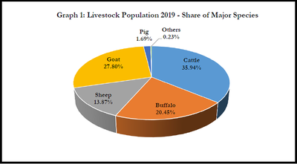](https://static.vikaspedia.in/media/images_en/agriculture/agri-directory/reports-and-policy-briefs/distribution-of-livestock-population/@@images/8f0bbe42-87a3-4309-acf3-74d5b30a2a75.png)

**Fig 1:** Livestock Population, Share of Major Livestock Species (Source: 20th Livestock census)

**Global Poultry Population**

The global poultry population has seen significant growth and transformation, becoming a critical component of the world’s food production system. Poultry, especially chickens, has emerged as a key source of protein and an economic driver in many countries. This section explores the current state, trends, and factors shaping the global poultry population, with a focus on major regional developments and future prospects.

Chickens, ducks, turkeys, and geese dominate the global poultry population, which continues to expand due to increasing demand for poultry meat and eggs. According to the Food and Agriculture Organization (FAO), poultry meat production has consistently grown, with chickens accounting for the largest share. This growth is driven by factors such as population growth, urbanization, rising incomes, and shifting dietary preferences toward lean protein sources.

Asia holds the largest share of the global poultry population, with countries like China, India, Indonesia, and Thailand being major producers. The region's growth is fueled by strong domestic demand and expanding export markets. Notably, chicken production has surged in Pakistan and Vietnam, partly as a response to shifts away from pork due to African Swine Fever (ASF).

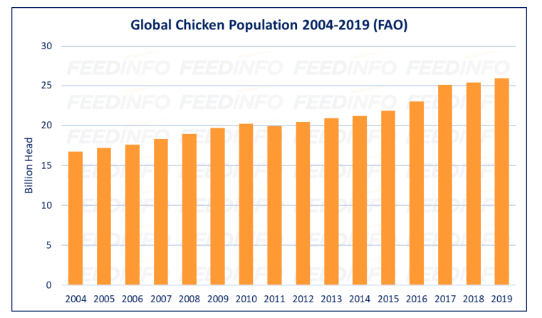

**Fig 2:** Global Chicken Population 2004-2019 (FAO) (Source: FEEDINFO, 2021)

**Poultry Population in India**

Based on the 20th Livestock Census, India’s total poultry population reached a record 851.81 million in 2019, marking a significant increase of 16.81% from the previous census in 2012, which recorded a population of 729.21 million.

**Indigenous Fowl**

The Fowl category is a high-yielding segment within poultry. Indigenous fowl are categorized into Desi (native) and Improved breeds. According to the 20th Livestock Census, fowls contribute nearly 94.84% of the total poultry population. The following table shows the breed-wise population of fowls under Backyard Poultry and Poultry Farms:

|  |  |  |  |  |
| --- | --- | --- | --- | --- |
| Breed Name | Backyard Poultry | Poultry Farm | Total | Percentage Share (%) |
| Miri | 54,03,648 | 7,445 | 54,11,093 | 0.7 |
| Daothigir | 36,94,955 | 1,302 | 36,96,257 | 0.5 |
| Kadaknath | 15,99,417 | 4,38,058 | 20,37,475 | 0.3 |
| Punjab Brown | 1,68,859 | 11,96,941 | 13,65,800 | 0.2 |
| Ankaleshwar | 7,02,147 | 6,19,859 | 13,22,006 | 0.2 |
| Chittagong | 23,855 | 12,17,145 | 12,41,000 | 0.2 |
| Busra | 9,95,386 | 2,23,338 | 12,18,724 | 0.2 |
| Ghagus | 4,55,230 | 3,05,734 | 7,60,964 | 0.1 |
| Kashmir Favorolla | 5,97,619 | 7 | 5,97,626 | 0.1 |
| Harringhata Black | 4,54,979 | 781 | 4,55,760 | 0.1 |
| Danki | 1,07,648 | 60,684 | 1,68,332 | - |
| Tellichery | 1,47,438 | 1,267 | 1,48,705 | - |
| Kaunayen | 1,10,706 | 4,122 | 1,14,828 | - |
| Mewari | 1,10,041 | 4,583 | 1,14,624 | - |
| Hasli | 85,733 | 5,652 | 91,385 | - |
| Kalahasthi | 11,736 | 38,000 | 49,736 | - |
| Nicobari | 25,641 | 974 | 26,615 | - |
| Total Desi Fowl | 4,08,32,670 | 1,16,68,843 | 5,25,01,513 | 6.5 |
| Other Desi Fowl | 18,67,31,428 | 5,31,78,591 | 23,99,10,019 | 29.7 |
| Improved Fowl | 5,32,09,966 | 46,22,31,485 | 51,54,41,451 | 63.8 |
| Total Fowl | 28,07,74,064 | 52,70,78,919 | 80,78,52,983 |  |

As shown in the table, Improved Fowl has the highest share with 63.8%, compared to 29.7% of Other Desi Fowl and 6.5% of Desi Fowls. Among the Desi Fowl population, Other Desi Fowl have the highest contribution at 82%, followed by Aseel (12%), Miri (2%), Daothigir (1%), and Kadaknath (1%). All other recognized breeds contribute 2% of the total fowl population.

**Egg and Meat Production**

**Egg Production:**

India’s egg production has grown steadily, making the country a major player in the global poultry industry. According to the "Basic Animal Husbandry Statistics - 2023," India produced 138.38 billion eggs in 2022-23, positioning it as the third-largest egg producer in the world. This section examines the trends, state-wise contributions, and factors influencing egg production in India.

Egg production in India increased by 6.77% from the previous year (2021-22). This rise is reflected in the per capita availability of eggs, which reached 101 eggs per annum in 2022-23, up from 95 eggs per annum in 2021-22. This consistent growth indicates improvements in poultry farming practices, enhanced productivity, and growing consumer demand for eggs as a nutritious food source.

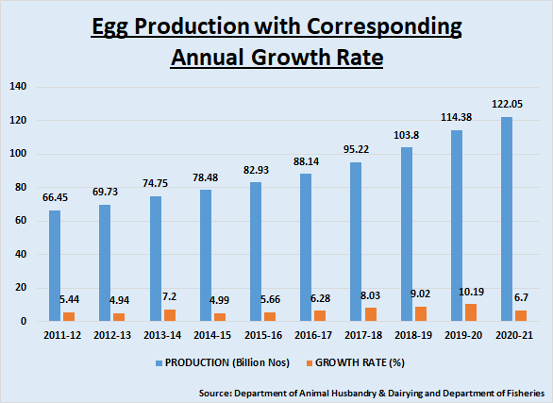

**Fig 3:** Egg Production with Annual Growth rate, 2011-2021

**Species-wise Contribution**

The species-wise breakdown of egg production in 2022-23 reveals that improved fowls are the predominant contributors, accounting for 88.41% of the total egg production. Desi fowls contribute 10.73%, while desi ducks and improved ducks contribute 0.74% and 0.12%, respectively. This distribution highlights the dominance of commercial poultry farming in India, with improved breeds playing a crucial role in meeting the high demand for eggs. India's egg production is concentrated in a few key states, with Andhra Pradesh, Tamil Nadu, and Telangana leading the way. These three states together account for nearly half of the country's total egg production.

* **Andhra Pradesh**: The largest producer, contributing 20.41% of the total egg production.
* **Tamil Nadu**: Second largest, with a share of 16.08%.
* **Telangana**: Third, contributing 12.86%.

Other significant contributors include West Bengal (8.84%) and Karnataka (6.38%). These five states together produce 64.93% of the total eggs in India, underscoring their critical role in the country's poultry industry.

[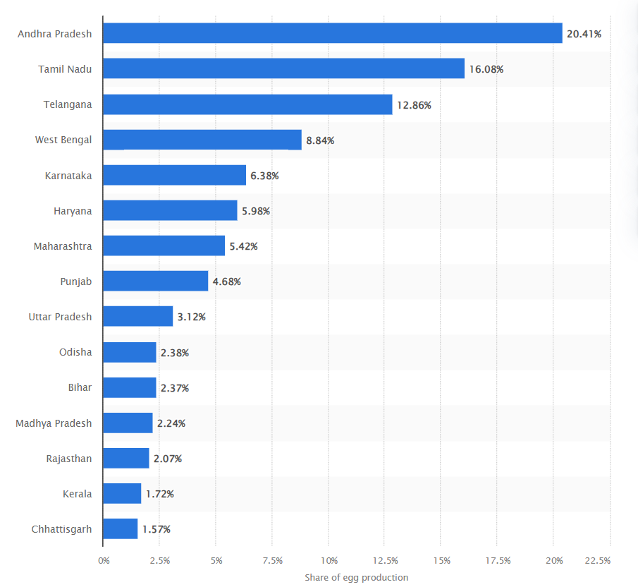](https://www.statista.com/statistics/1357100/india-egg-production-share-by-major-state/)

**Fig 4:** Distribution of egg production in India during financial year 2022

**Per Capita Availability of Eggs:**

The per capita availability of eggs is a key indicator of both production efficiency and consumption patterns. In 2022-23, nine states exceeded the national average of 101 eggs per annum, highlighting regional disparities influenced by dietary preferences, economic conditions, and local farming practices.

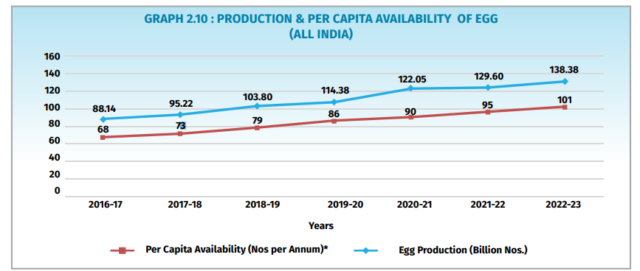

**Fig 5:** Production & per capita availability of egg (Source: Basic Animal Husbandry Statistics – 2023)

**Meat Production:**

Poultry meat production has become a critical part of India’s meat industry, contributing significantly to overall meat production. In 2022-23, poultry meat dominated the sector, reflecting growth, technological advancements, and increasing consumer demand. This section offers a comprehensive overview of poultry meat production in India, including its contribution, growth trends, and influencing factors.

Poultry accounted for 51.14% of India’s total meat production in 2022-23, with other livestock like buffalo, goat, sheep, pig, and cattle contributing smaller percentages. The total meat production in the country rose from 7.39 million tonnes in 2016-17 to 9.77 million tonnes in 2022-23, driven largely by poultry. The annual growth rate for meat production, including poultry, was 5.13% in 2022-23.

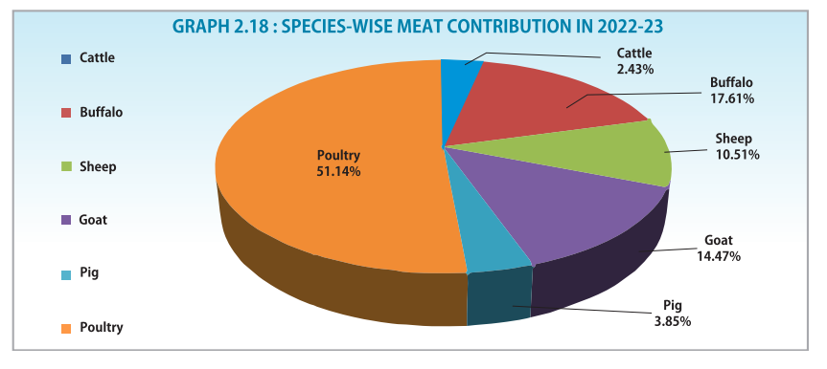

**Fig 6:** Species-Wise Meat Contribution, 2022-23 (Source: Basic Animal Husbandry Statistics – 2023)

The total Meat production in the country was at 9.77 Million Tonnes in the year 2022-23. The per capita availability was 5.72 kg per annum during the period 2016-17. There has been steady increase in per capita availability of Meat. The per capita availability reached at 7.10 Kg/Annum the year 2022-23, a 0.28-point jump from 6.82 Kg/Annum of the previous year 2021-22.

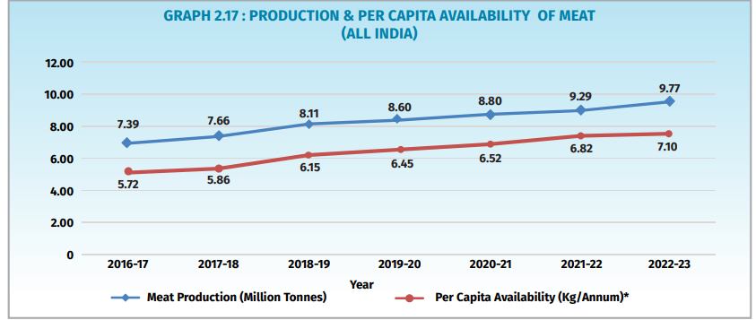

**Fig 7:** Production & per capita availability of meat (Source: Basic Animal Husbandry Statistics – 2023)

**Breeding Farms for Diverse Livestock**

India's diverse livestock population requires specialized breeding farms tailored to its varied needs. Poultry breeding is another vital aspect of India's agricultural landscape, with 6,227 farms highlighting its importance to the economy. The infrastructure for breeding poultry and other birds is well-developed, including 40 duck breeding farms, 34 of which are managed by the government and six by private entities.

This comprehensive and well-organized infrastructure ensures the efficient management and development of India's animal husbandry sector, supporting millions of livelihoods and making a significant contribution to the national economy.

**Conclusion**

Backyard and commercial poultry farming are essential components of India’s agricultural landscape. The sector has experienced significant growth, fueled by traditional backyard practices and the rise of organized commercial operations. Backyard poultry farming is deeply embedded in rural communities, serving as a vital source of income, nutrition, and social security. It has grown by nearly 46% between 2012 and 2019, reflecting the effectiveness of government support and the resilience of rural economies.

On the other hand, commercial poultry farming has evolved into a highly organised industry that plays a substantial role in the national economy. With a 4.5% growth during the same period, it has benefited from increasing demand, urbanization, and technological advancements. The industry's ability to provide affordable protein and employment highlights its economic importance. India’s poultry sector demonstrates the potential for sustainable growth and the importance of fostering a balanced approach to both traditional and modern farming practices.

**Reference:**

*Agricultural Statistics at a Glance 2021* (1st ed., p. 431). Government of India Ministry of Agriculture & Farmers Welfare Department of Agriculture & Farmers Welfare Directorate of Economics & Statistics. [www.agricoop.nic.in](http://www.agricoop.nic.in) & <https://desagri.gov.in>

*2019 Global Livestock Population – FAO Data*. FAOSTAT. <https://www.fao.org/statistics/en/>

*Annual Report 2021-2022* (pp. 141-144). Department of Animal Husbandry and Dairying Ministry of Fisheries, Animal Husbandry and Dairying Government of India.

*Basic Animal Husbandry Statistics - 2023* (pp. 15-22). Government of India Ministry of Fisheries Animal Husbandry and Dairying Ministry of Animal Husbandry and Dairying Krishi Bhawan, New Delhi.

*Breed-Wise Report Of Livestock And Poultry Based on 20th Livestock Census* (pp. 67-75). Government of India Ministry of Fisheries Animal Husbandry and Dairying Ministry of Animal Husbandry and Dairying Krishi Bhawan, New Delhi. <https://dahd.nic.in/ahs-division/20th-livestock-census-2019-all-india-report>.

Naik, P. K., Swain, B. K., & Beura, C. K. (2022). Duck production in India - A review. *Indian Journal of Animal Sciences*, *92*(8), 917-926.

<https://doi.org/10.56093/ijans.v92i8.118712>.

Jairath, G., Gopinath, D., Rialch, A., Singh, P., Radotra, S., & Bishnoi, S. (2022, June 14). *Overview of the Indian Meat Industry*. SR PUBLICATIONS. Retrieved August 3, 2024, from <https://www.srpublication.com/overview-of-the-indian-meat-industry/#:~:text=Half>

*Brief note on 9 Years' achievement of Department of Animal Husbandry & Dairying*. Press Information Bureau. Retrieved August 3, 2024, from <https://pib.gov.in/PressReleaseIframePage.aspx?PRID=1935628&trk=public_post_comment-text>